Chick–fil–A
Pre–Concert Dinner
Thursday December 13
Food served between 5-7 pm
Chick-fil-A Sandwich ________
$7.50 Quantity
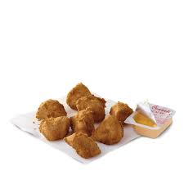
Eight Piece Nuggets ________
$7.50 Quantity
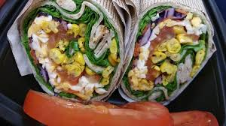
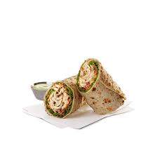
Veggie Wrap ________
$7.50 Quantity
Grilled Chicken Wrap ________
$9.00 Quantity
*All entrees include chips, drink, and dessert
$_____________
Total Due
Cash or Check Payable to “OCMS 360”
Please return PRE-sale order form and payment to Mr. Wise no later than
Friday, December 7

____________________________________________________________________
Students Last Name First Name Grade
Chick–fil–A
Pre–Concert Dinner
Thursday December 13
Food served between 5-7 pm
Chick-fil-A Sandwich ________
$7.50 Quantity
Eight Piece Nuggets ________
$7.50 Quantity
Veggie Wrap ________
$7.50 Quantity
Grilled Chicken Wrap ________
$9.00 Quantity
*All entrees include chips, drink, and dessert
$_____________
Total Due
Cash or Check Payable to “OCMS 360”
Please return PRE-sale order form and payment to Mr. Wise no later than
Friday, December 7

____________________________________________________________________
Students Last Name First Name Grade

